**All the databases are created using Mysql**

**Task1** :

**Project Title: Academic Management System**

Project Description:

Design and develop an Academic Management System using SQL. The projects should involve

three tables 1.StudentInfo 2. CoursesInfo 3.EnrollmentInfo. The Aim is to create a system that

allows for managing student information and course enrollment. The project will include the

following tasks:

**1.Database Creation:**

a)Create the StudentInfo table with columns STU_ ID, STU_NAME, DOB, PHONE_NO,

EMAIL_ID,ADDRESS.

- CREATE TABLE StudentInfo (

STU_ID INT PRIMARY KEY,

STU_NAME VARCHAR(100),

DOB DATE,

PHONE_NO VARCHAR(15),

EMAIL_ID VARCHAR(100),

ADDRESS VARCHAR(255)

);

b)Create the CoursesInfo table with columns COURSE_ID,

COURSE_NAME,COURSE_INSTRUCTOR NAME.

CREATE TABLE CoursesInfo (

COURSE_ID INT PRIMARY KEY,

COURSE_NAME VARCHAR(100),

COURSE_INSTRUCTOR_NAME VARCHAR(100)

);

c)Create the EnrollmentInfo with columns ENROLLMENT_ID, STU_ ID, COURSE_ID,

ENROLL_STATUS(Enrolled/Not Enrolled). The FOREIGN KEY constraint in the EnrollmentInfo

table references the STU_ID column in the StudentInfo table and the COURSE_ID column in the CoursesInfo table.

CREATE TABLE EnrollmentInfo (

ENROLLMENT_ID INT PRIMARY KEY,

STU_ID INT,

COURSE_ID INT,

ENROLL_STATUS ENUM('Enrolled', 'Not Enrolled'),

FOREIGN KEY (STU_ID) REFERENCES StudentInfo(STU_ID),

FOREIGN KEY (COURSE_ID) REFERENCES CoursesInfo(COURSE_ID)

);

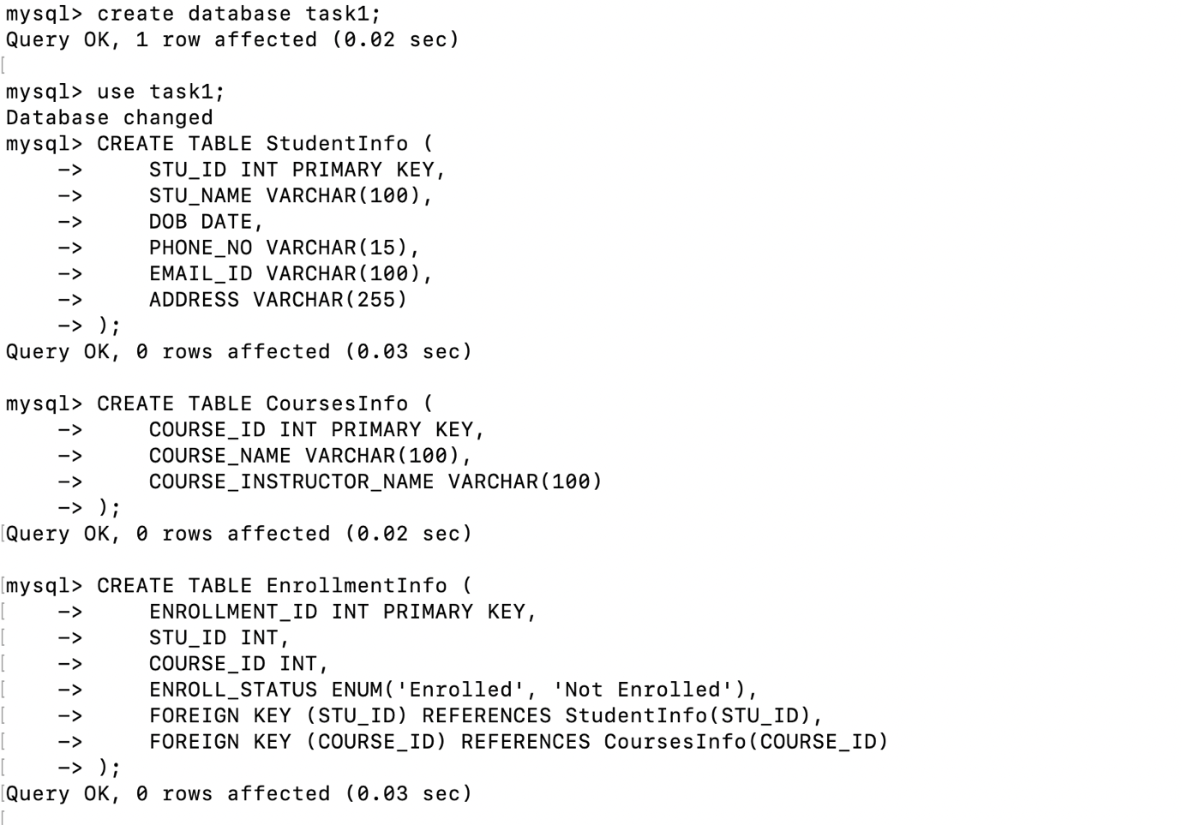

2.Data Creation:

Insert some sample data for StudentInfo table , CoursesInfo table, EnrollmentInfo with

respective fields.

INSERT INTO StudentInfo (STU_ID, STU_NAME, DOB, PHONE_NO, EMAIL_ID, ADDRESS)

VALUES

(1, 'Ruchika Ajmera', '2000-01-15', '123-456-7890', 'ruchika.ajmera@example.com', '123 Street'),

(2, 'Ruchi ', '1999-02-22', '234-567-8901', 'Ruchi@example.com', 'whitefield'),

(3, 'Ruch Ajm', '2001-03-30', '345-678-9012', 'ruchajm@example.com', 'xyz road');

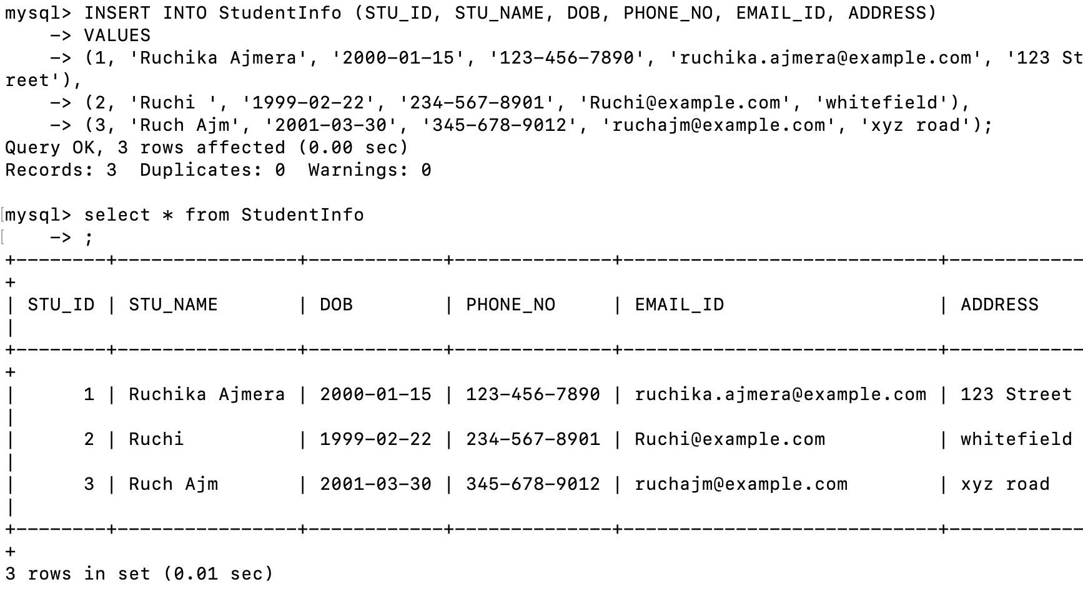

INSERT INTO CoursesInfo (COURSE_ID, COURSE_NAME, COURSE_INSTRUCTOR_NAME)

VALUES

(101, 'Introduction to SQL', 'Shinto'),

(102, 'Advanced Programming', 'Prof. Shinto'),

(103, 'Data Structures', 'Striver');

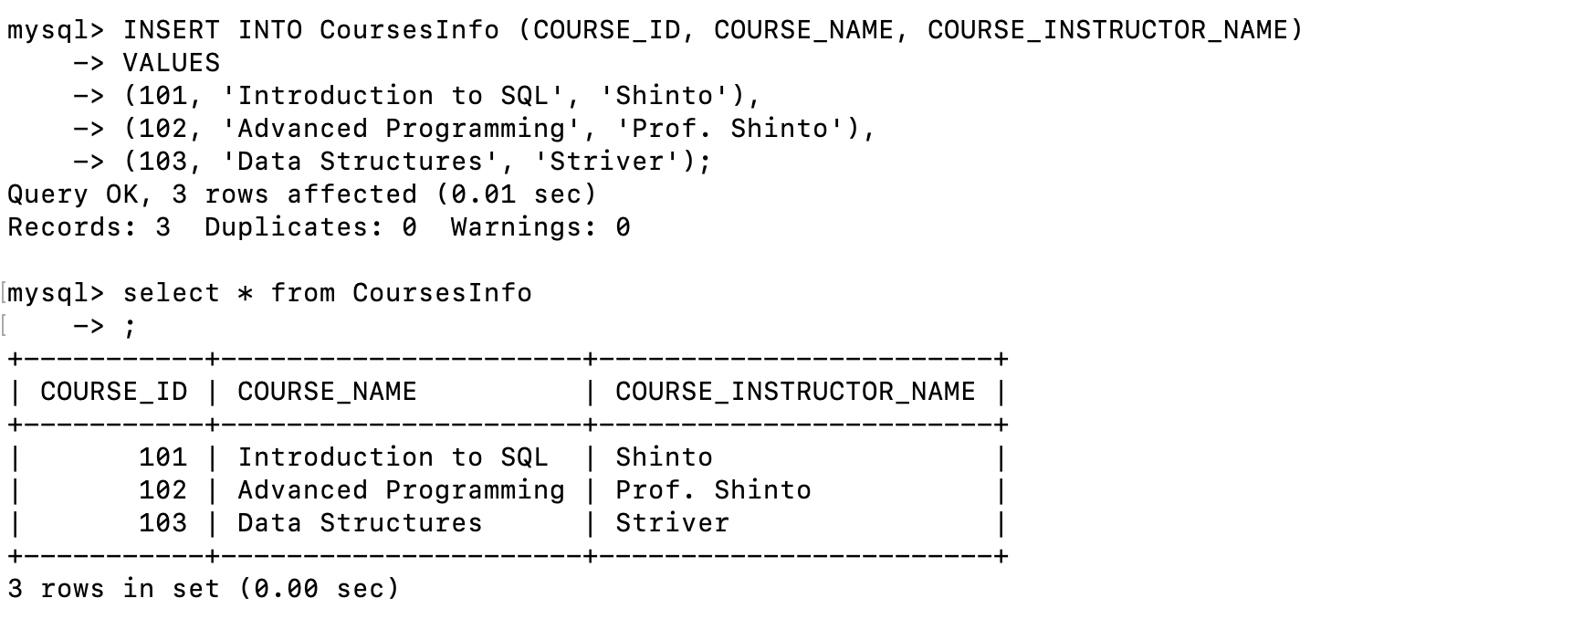

INSERT INTO EnrollmentInfo (ENROLLMENT_ID, STU_ID, COURSE_ID, ENROLL_STATUS)

VALUES

(1, 1, 101, 'Enrolled'),

(2, 1, 102, 'Not Enrolled'),

(3, 2, 101, 'Enrolled'),

(4, 2, 103, 'Enrolled'),

(5, 3, 102, 'Enrolled');

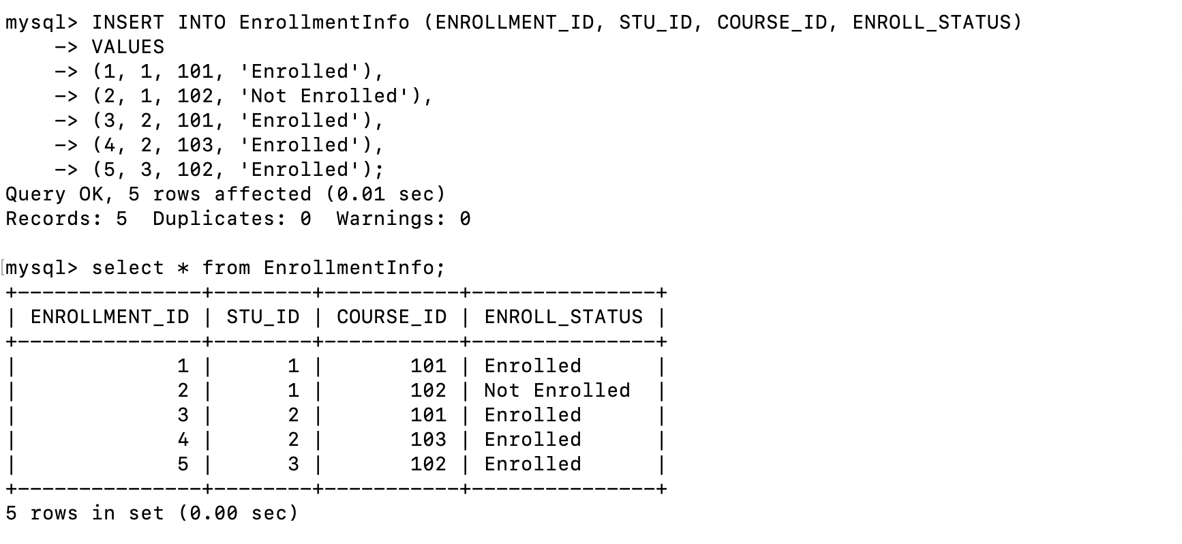

3) Retrieve the Student Information

a) Write a query to retrieve student details, such as student name, contact informations, and

Enrollment status.

SELECT s.STU_NAME, s.PHONE_NO, s.EMAIL_ID, e.ENROLL_STATUS

FROM StudentInfo s

JOIN EnrollmentInfo e ON s.STU_ID = e.STU_ID;

b) Write a query to retrieve a list of courses in which a specific student is enrolled.

SELECT c.COURSE_NAME

FROM CoursesInfo c

JOIN EnrollmentInfo e ON c.COURSE_ID = e.COURSE_ID

WHERE e.STU_ID = 1 AND e.ENROLL_STATUS = 'Enrolled';

c) Write a query to retrieve course information, including course name, instructor information.

SELECT COURSE_NAME, COURSE_INSTRUCTOR_NAME

FROM CoursesInfo;

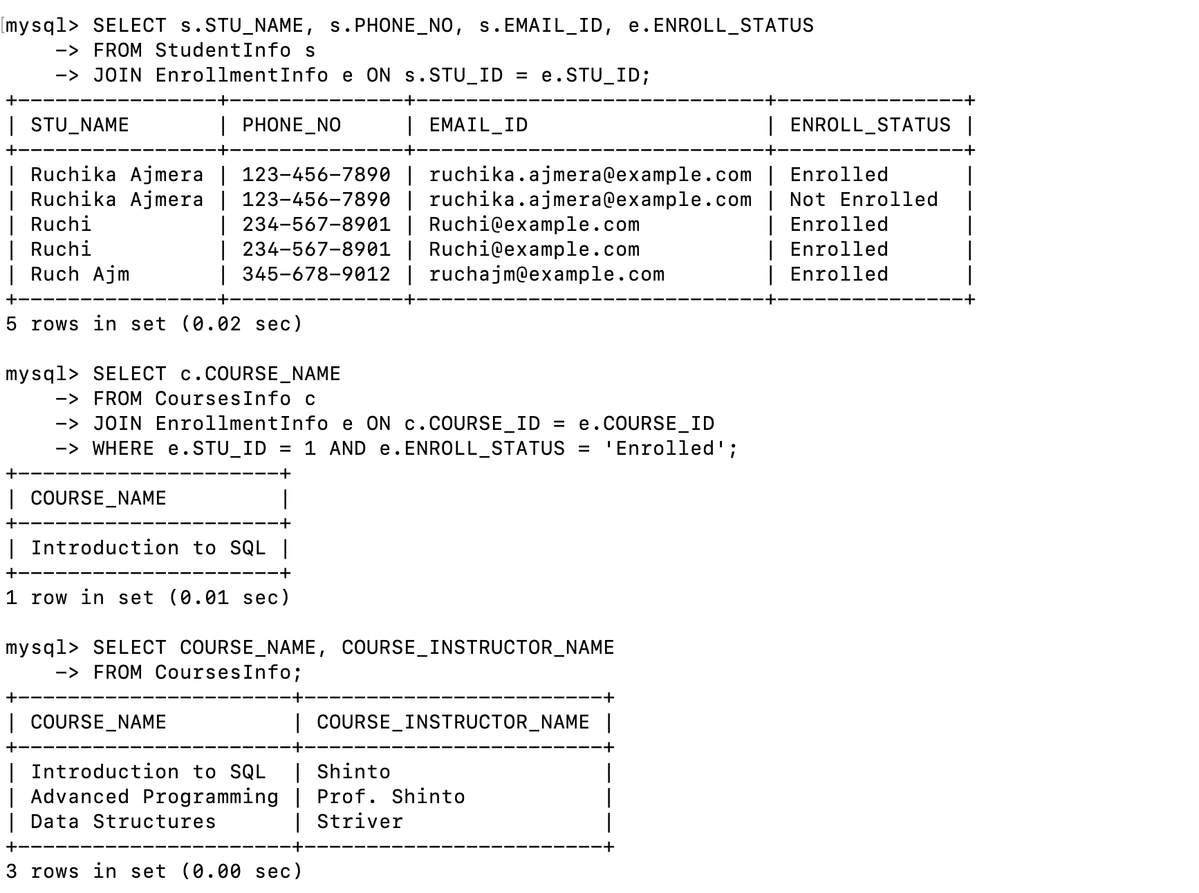

d) Write a query to retrieve course information for a specific course .

SELECT COURSE_NAME, COURSE_INSTRUCTOR_NAME

FROM CoursesInfo

WHERE COURSE_ID = 101;

e) Write a query to retrieve course information for multiple courses.

SELECT COURSE_NAME, COURSE_INSTRUCTOR_NAME

FROM CoursesInfo

WHERE COURSE_ID IN (101, 102);

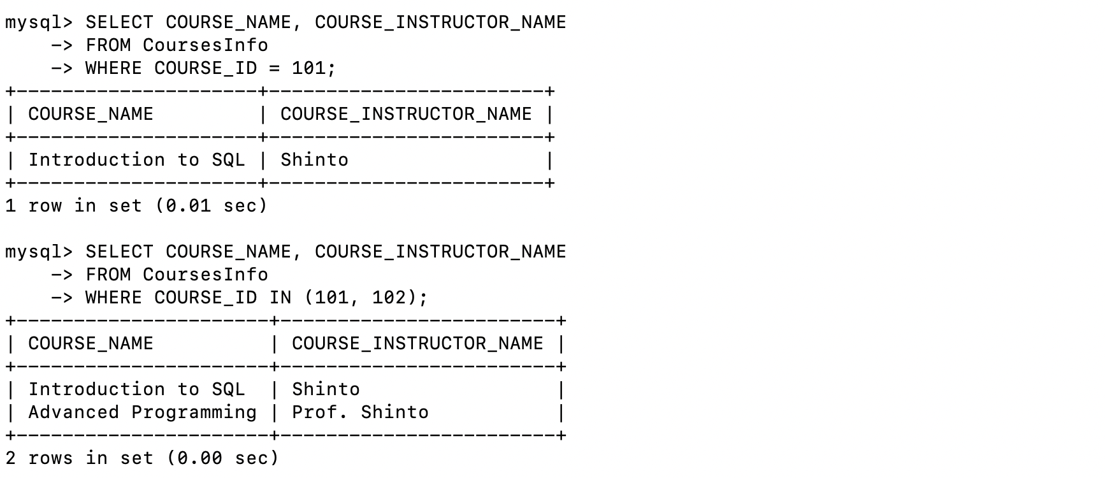

4. Reporting and Analytics (Using joining queries)

a) Write a query to retrieve the number of students enrolled in each course

SELECT c.COURSE_NAME, COUNT(e.STU_ID) AS num_students

FROM CoursesInfo c

LEFT JOIN EnrollmentInfo e ON c.COURSE_ID = e.COURSE_ID AND e.ENROLL_STATUS = 'Enrolled'

GROUP BY c.COURSE_NAME;

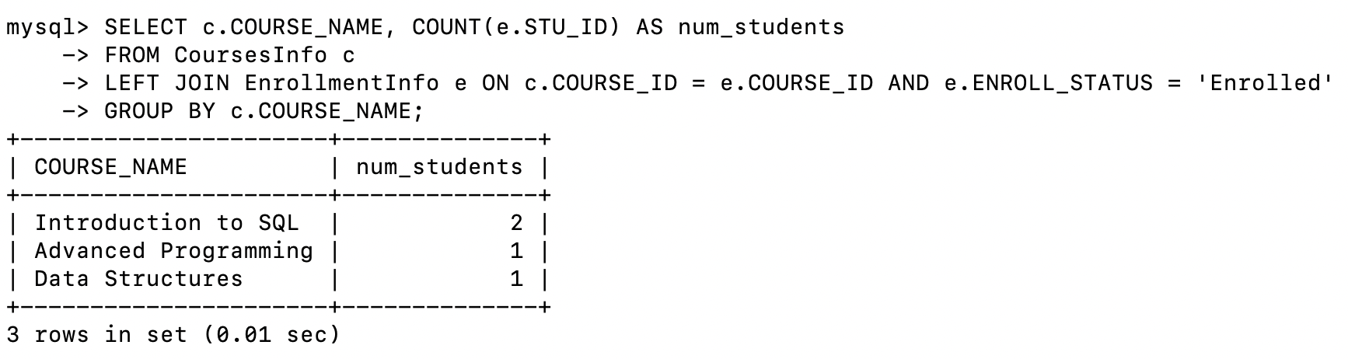

b) Write a query to retrieve the list of students enrolled in a specific course

SELECT s.STU_NAME

FROM StudentInfo s

JOIN EnrollmentInfo e ON s.STU_ID = e.STU_ID

WHERE e.COURSE_ID = 101 AND e.ENROLL_STATUS = 'Enrolled';

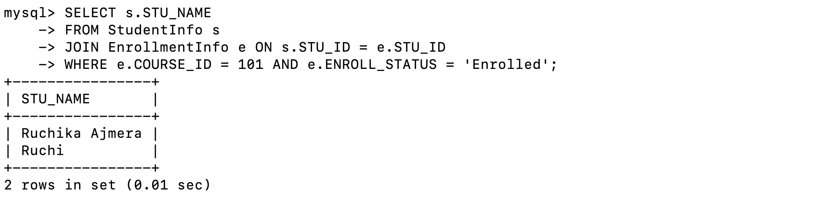

c) Write a query to retrieve the count of enrolled students for each instructor.

SELECT c.COURSE_INSTRUCTOR_NAME, COUNT(e.STU_ID) AS num_students

FROM CoursesInfo c

LEFT JOIN EnrollmentInfo e ON c.COURSE_ID = e.COURSE_ID AND e.ENROLL_STATUS = 'Enrolled'

GROUP BY c.COURSE_INSTRUCTOR_NAME;

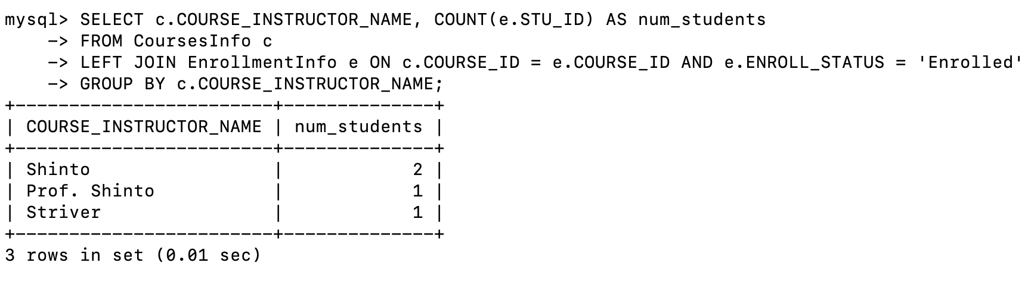

d) Write a query to retrieve the list of students who are enrolled in multiple courses

SELECT s.STU_NAME

FROM StudentInfo s

JOIN EnrollmentInfo e ON s.STU_ID = e.STU_ID

WHERE e.ENROLL_STATUS = 'Enrolled'

GROUP BY s.STU_NAME

HAVING COUNT(e.COURSE_ID) > 1;

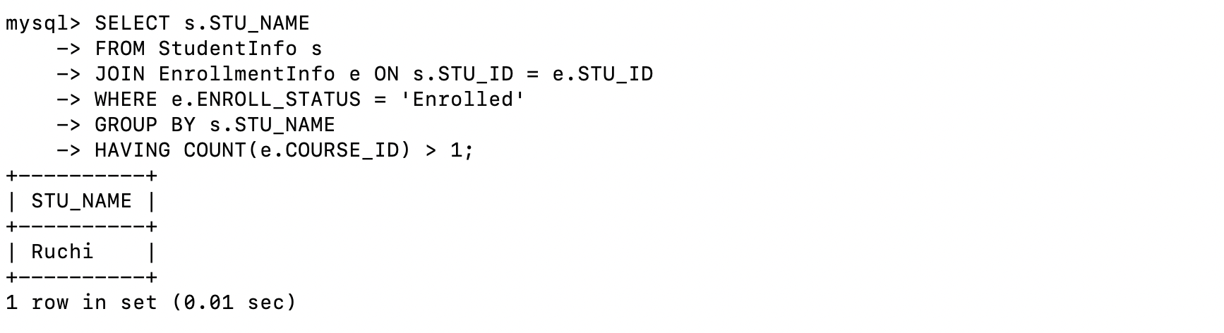

e) Write a query to retrieve the courses that have the highest number of enrolled

students(arranging from highest to lowest)

SELECT c.COURSE_NAME, COUNT(e.STU_ID) AS num_students

FROM CoursesInfo c

LEFT JOIN EnrollmentInfo e ON c.COURSE_ID = e.COURSE_ID AND e.ENROLL_STATUS = 'Enrolled'

GROUP BY c.COURSE_NAME

ORDER BY num_students DESC;

